If you cannot remember your password

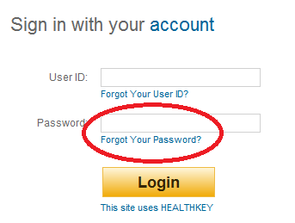
- Click on Forgot Your Password

- Enter your user ID
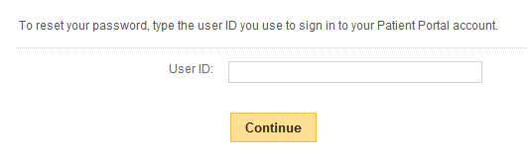

- Enter the answer to your secret question that your created during registration and enter a new password
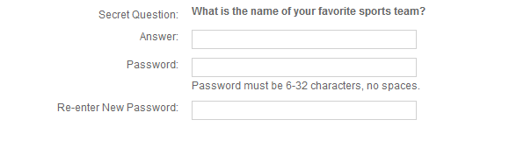

- You will receive a confirmation message
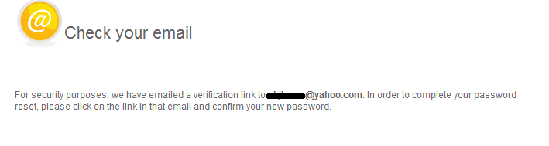

- You will soon receive an email for your to confirm your new password
